DEPARTMENT OF ELECTRICAL ENGINEERING & ELECTRONICS

November update for project ‘Passive dynamic slope-walking bipedal robot’
Author: Jadyn Ross (201640204)
Project Supervisor: Heba Lakany
Project Assessor: Barry Smith

Declaration of academic integrity

By submitting this work, I confirm that I have read and understood the University’s Academic Integrity Policy.
By submitting this work, I confirm that I have acted honestly, ethically and professionally in conduct leading to assessment for the programme of study.
By submitting this work, I confirm that the work I am submitting is my own. I have not commissioned production of the work from a third party or used artificial intelligence software in an unacceptable manner to generate the work*. I have not copied material from another person or source, nor committed plagiarism, nor fabricated, falsified or embellished data when completing the attached piece of work. I have not colluded with any other student in the preparation and/ or production of this work.
*Software applications include but are not limited to, ChatGPT, Bing Chat, DALL.E, Bard

November Progress Report:

Following literature review of critical research papers by Tad McGeer and Collins et al., I identified leg mechanics as the fundamental component of bipedal locomotion. My project research and implementation progressed through a series of clear phases:

Phase 1 - Theoretical foundation: I studied human gait biomechanics, analyzing the phases of each leg during walking: heel strike, mid-stance, toe-off, and swing. I investigated joint constraints and established the theoretical basis for passive dynamic walking.

Phase 2 - Simple simulation (Jupyter Lab): With AI assistance, I developed an interactive Jupyter Lab environment to strengthen my practical and mathematical understanding before implementation. I accomplished this by modifying existing double inverted pendulum code from “touhidulislam1999” on GitHub. This allowed me to experiment with leg dynamics, joint restrictions, and limb velocities in a rapid-prototyping environment before committing to a more complex physics simulation.

Parameters for simulation:
- Max_knee = 65 degress
- Thigh_length = 0.45m
- Shin_length = 0.43m
- Thigh_mass = 7kg
- Shin_mass = 3.5kg
- Gravity = 9.81

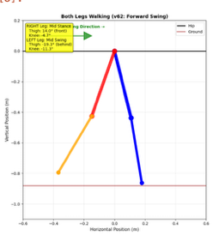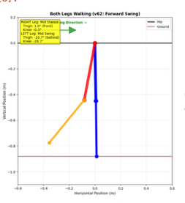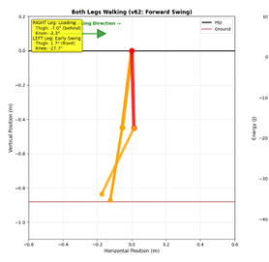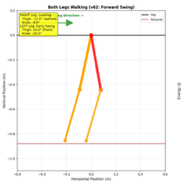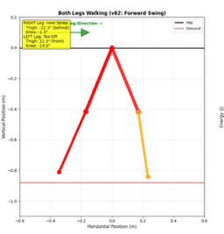
Screenshots from jupyter lab simulation

Phase 3 - Complex physics simulation (PyBullet): Utilising the Jupyter Labs modelling and code I transitioned to PyBullet. This development will allow me to utilize a complex physics engine providing accurate collision detection, ground contact forces, and continuous dynamics modeling. This simulation environment enables validation of parameters without the material waste/trial and error of physical prototypes.

I am currently designing the PyBullet simulation, where I must validate parameters to ensure stable, repeatable walking gaits that can be confidently translated into CAD models for further simulation, 3D printing and physical testing. Although following my project plan briefly in the beginning, I have come to realise that some sections will require a lot more time and effort than previously scheduled – such as simulating walking dynamics, parameter choices etc. My decision is to reduce time spent on CAD design, and more on the modelling and simulation. I have not yet updated my project plan.

